Linux Basics Submission
Tasks:
1. Creating and Renaming Files/Directories
Create a directory named test_dir using mkdir.
Inside test_dir, create an empty file called example.txt.
Rename example.txt to renamed_example.txt using mv

2. Viewing File Contents
Use cat to display the contents of /etc/passwd.
Display only the first 5 lines of /etc/passwd using head.
Display only the last 5 lines of /etc/passwd using tail.

3.Searching for Patterns
Use grep to find all lines containing the word "root" in /etc/passwd.

4. Zipping and Unzipping
Compress the test_dir directory into a file named test_dir.zip using zip.
Unzip test_dir.zip into a new directory named unzipped_dir.

5. Downloading Files
Use wget to download a file from a URL (e.g., https://example.com/sample.txt).

6. Changing Permissions
Create a file named secure.txt and change its permissions to read-only for everyone using chmod.

7. Working with Environment Variables
Use export to set a new environment variable called MY_VAR with the value "Hello, Linux!"

Screenshots:
1:
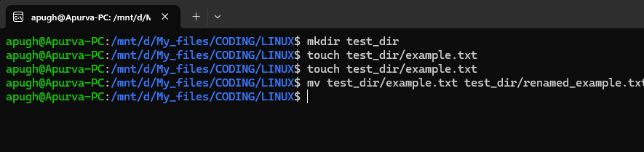
2:
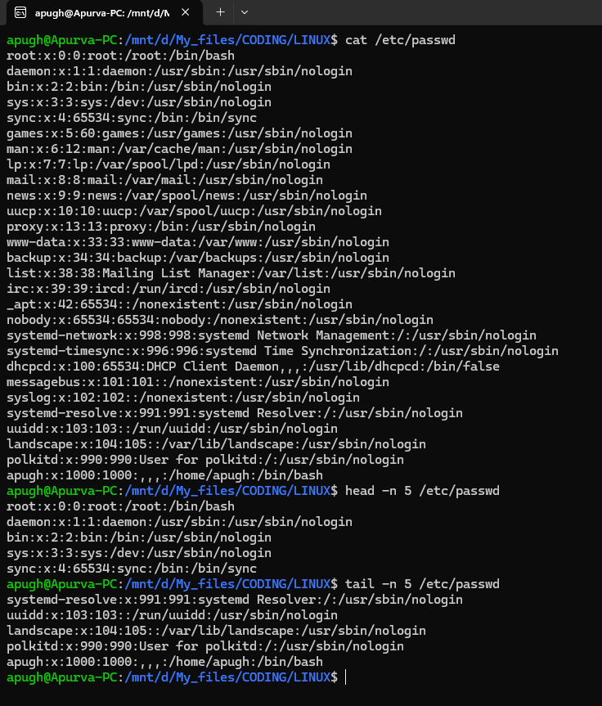
3:
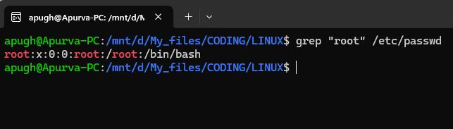

4: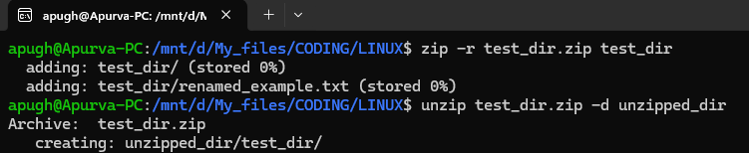

5.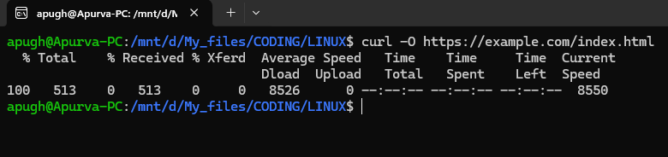

6.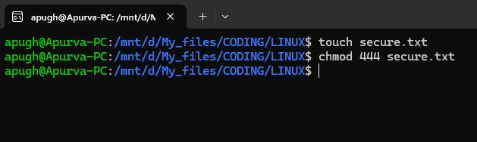
7.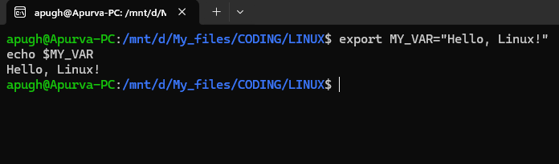

Commands:
1>
mkdir test_dir
touch test_dir/example.txt
mv test_dir/example.txt test_dir/renamed_example.txt

2>
cat /etc/passwd
head -n 5 /etc/passwd
tail -n 5 /etc/passwd

3>
grep "root" /etc/passwd

4>
zip -r test_dir.zip test_dir
unzip test_dir.zip -d unzipped_dir

5>
wget https://example.com/index.html

6>
touch secure.txt
chmod 444 secure.txt

7>
export MY_VAR="Hello, Linux!"
echo $MY_VAR

